**SHOWING ELEVTION ALONG A PATH**

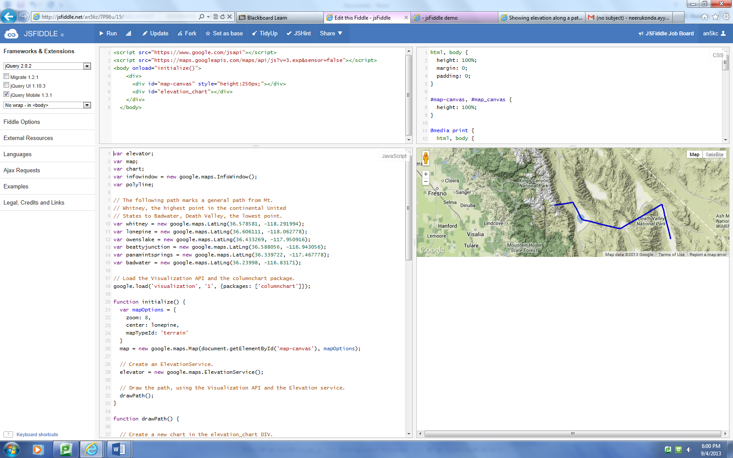

Result after executing the code. To view this go to the link <http://jsfiddle.net/an5kc/7P98u/17/>

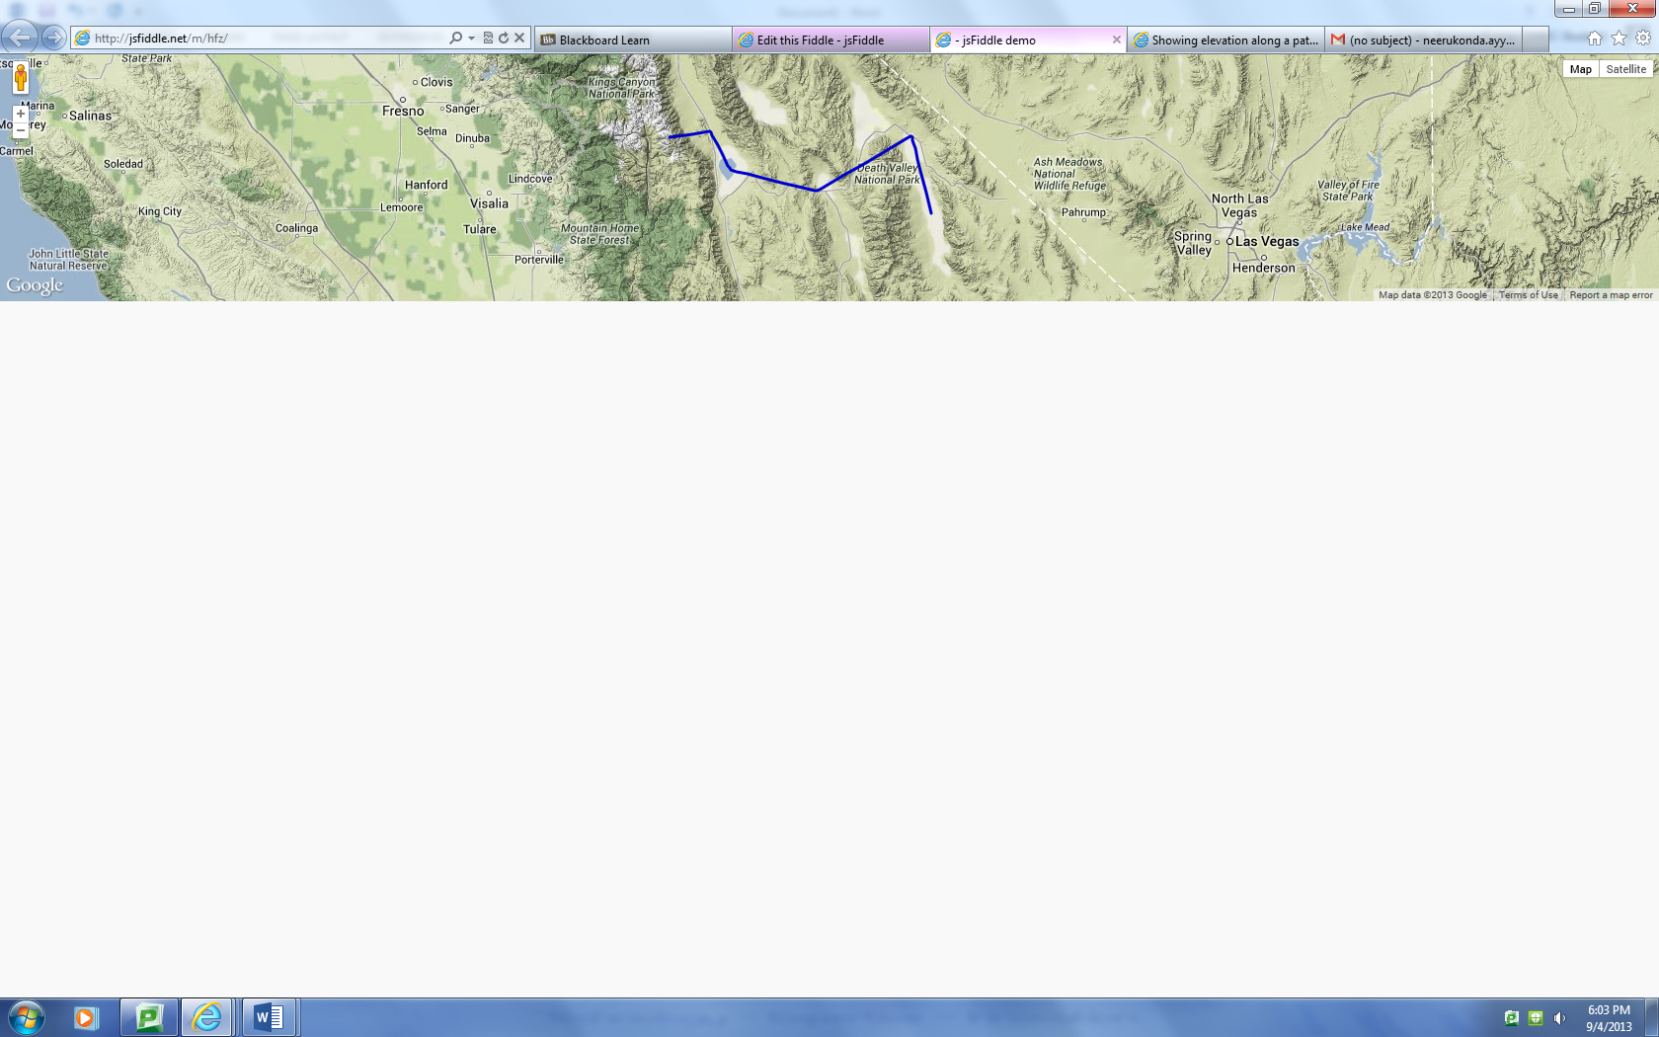

It is the output when we implement it as mobile web application.